**Test Results**

1. Enter User Name,Post Title, Views,Likes & Press Submit

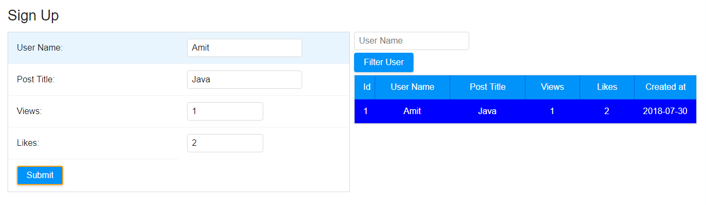

1. Delete all values from the sign up form

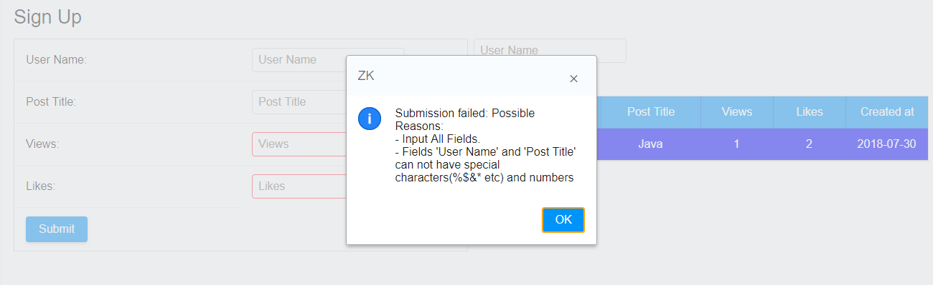

1. Enter User Name, Post title, Leave Views and Likes blank and Submit

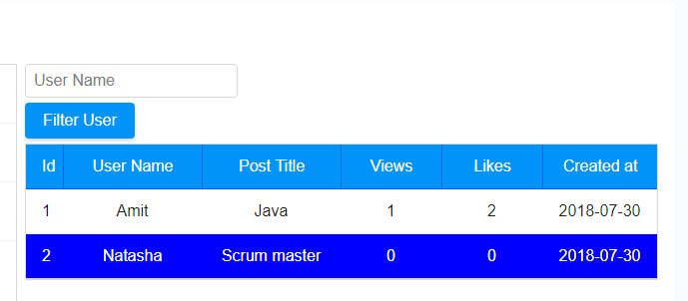

1. Enter User Name,Post Title, Views,Likes & Press Submit

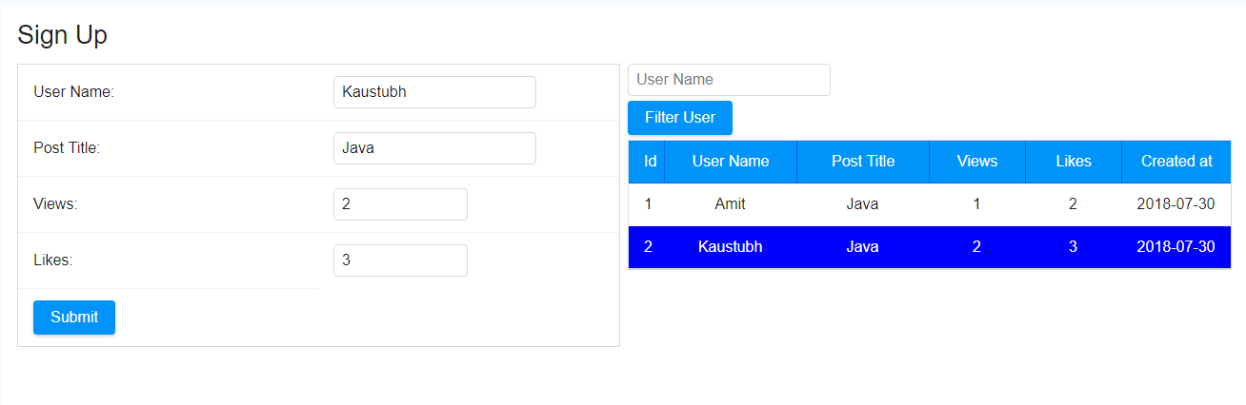

1. Enter User Name & Post title with spaces

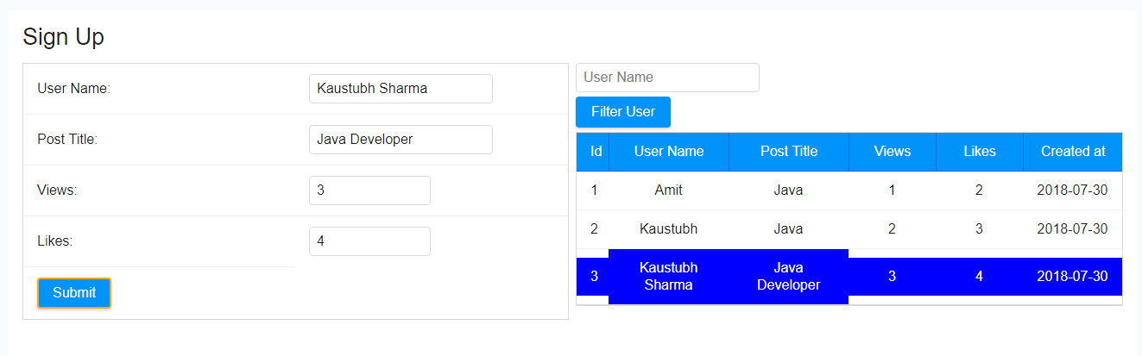

1. Enter a long User Name & post title ( max Limit 20) , likes & Views (max limit 9) & press Submit

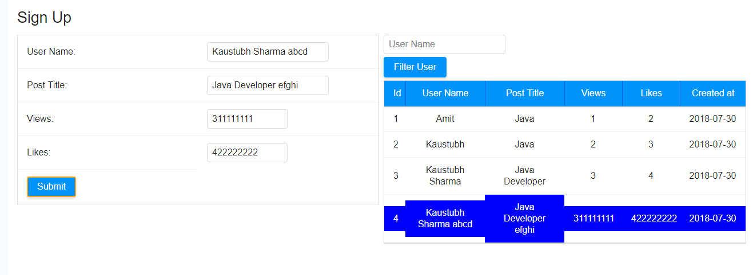

1. Enter an existing User Name in the side grid and press filter user

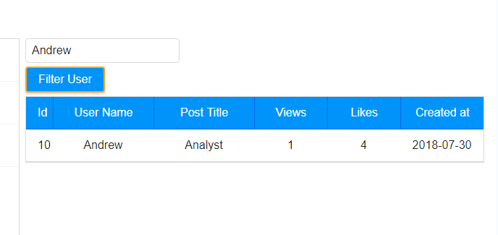

1. Enter a non existing User Name in the side grid and press filter user

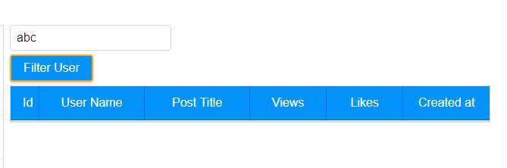

1. Delete filter user name

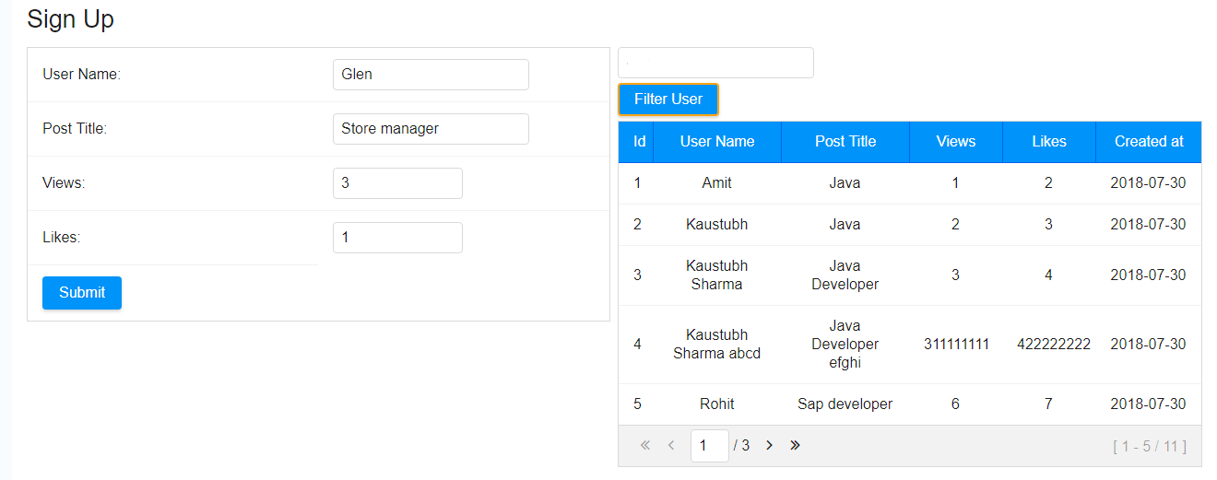

1. Sort On user Id, User Name, Post Title,Views, Likes

**Below Figure Sorted by User Name**

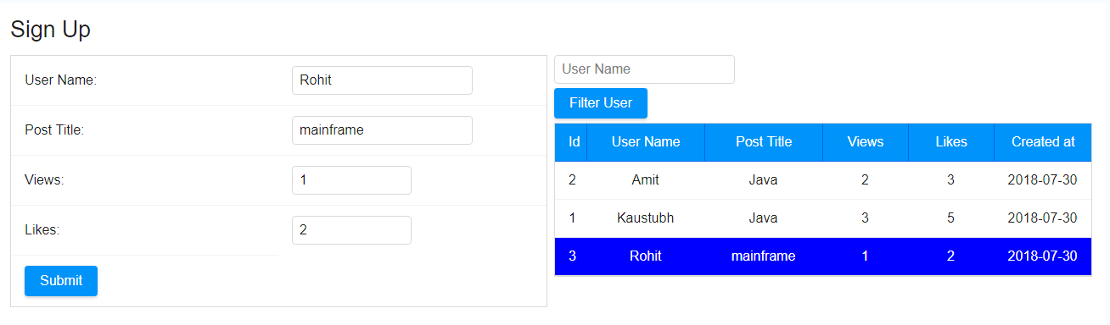

**Below Figure Sorted by Post Title**

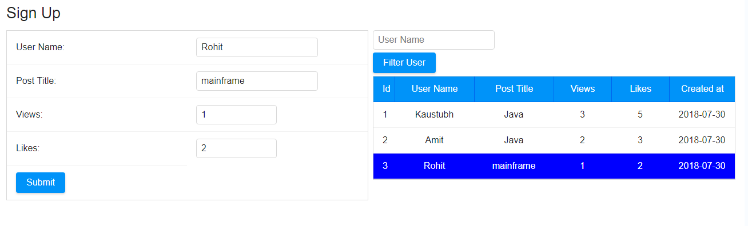

1. Enter 10 User Details

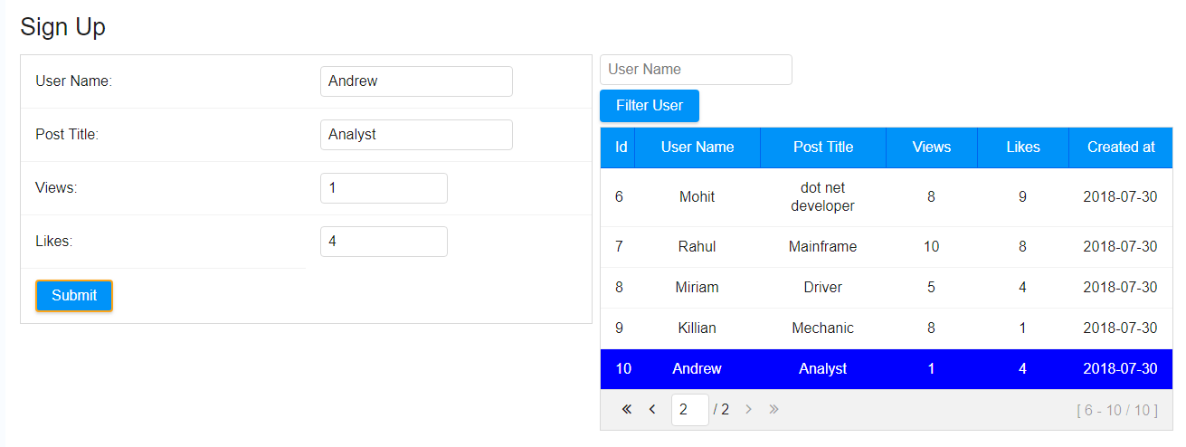

1. Filter User on Existing User Name & Enter a new User from Sign up form

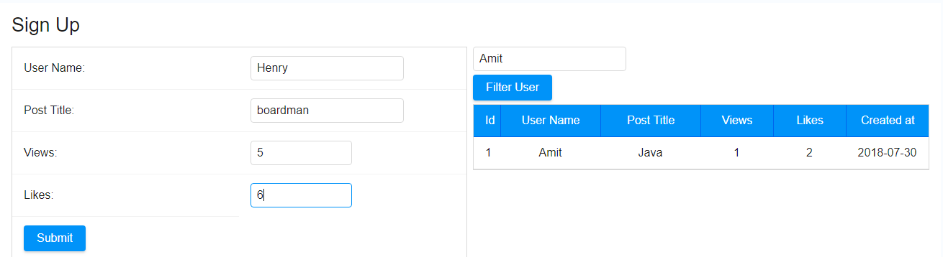

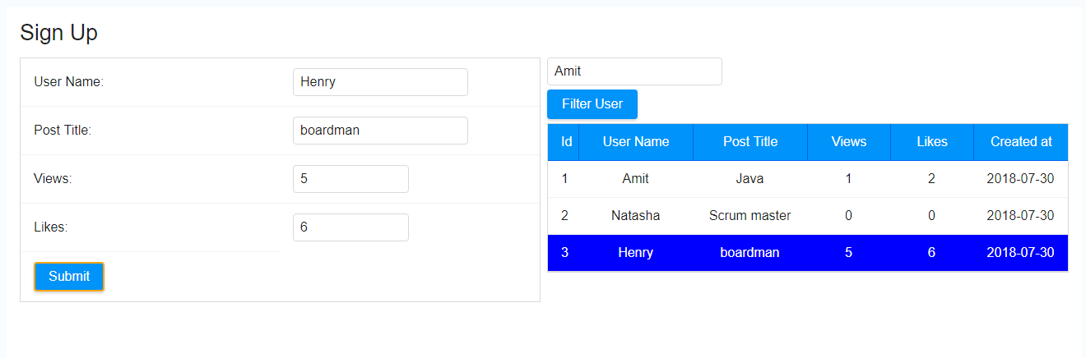

1. Sign up form

